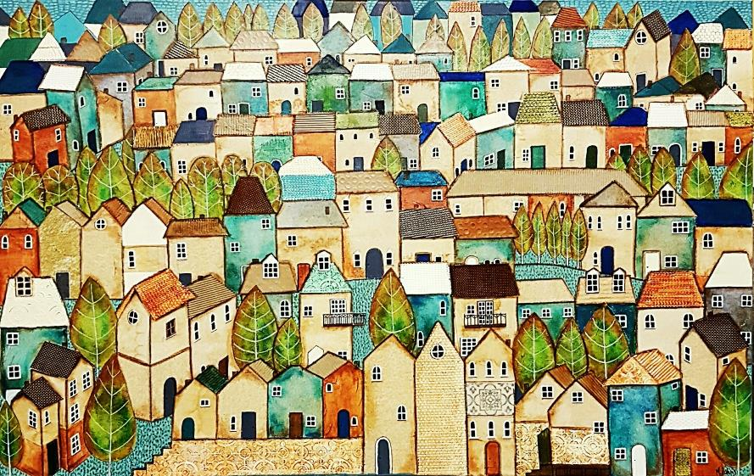 | Melissa Johns  0458 822 886  10 Moore Street,  Wangaratta VIC 3677  E: MisscycledART@gmail.com  FB: Miss Johns - Misscycled ART  @missjohns_art  www.missjohns.com

1

Professional Profile | I create my pieces using Recycled T E A B A G S and other recyclables. I chose these mediums as I wanted to work with sustainable materials that would lend my work a certain whimsical feel. In 2015 I began my journey of creating pieces using the teabag fabric on canvases as part of a collage, along with other recyclables; coffee cups, serviettes, gift bags, coffee filters etc. My process involves painting and drawing on each individual piece of teabag fabric (i.e. every colour represents a different collaged piece of fabric), which I then collage onto a canvas. My process is a lengthy one, with pieces taking anywhere from 1 to 5 weeks to complete. Other mediums I use in this process are charcoal, pastels & watercolours, with acrylic base on occasion.
Artist Statement | I have always enjoyed creating & believe I have a keen imagination and a vast pool of passion for my art. 2015 saw me begin to create on canvas where I discovered my love of using recyclable materials; this led to me experimenting with different mediums. I discovered a biased & unconditional love of tea bag fabric, painted & collaged onto canvas to create scenic pieces. My work has been described as Naïve and Whimsical, to Contemporary, to Abstract. My wish is for my pieces to find loving homes that will cherish them, to raise intrigue for the viewer and awe for the buyer, and for my work to remain my passion for years to come.
Solo Exhibition | Wangaratta Art Space, ‘A Tribute to Tea’, September 2017  Wangaratta Jazz Festival, Milawa Art Show, October 2017
Awards | Viewer’s Choice Award St. Bernard’s Art Show 2016  Viewer’s Choice Award A Feast Of Art, Oxley art show 2016  Viewer’s Choice Award St. Bernard’s Art Show 2017  Emerging Artist Award King Valley Art Show 2017  Commendation St Augustine’s Art Show 2016, 2017, 2018  Commendation King Valley Art Show 2016  Commendation Camberwell Art Show 2017  Commendation St Bernard’s Art Show 2017  Commendation Bright Art Show 2018  Commendation St. Bernard’s Art Show 2018  Viewer’s Choice Award St. Bernard’s Art Show 2018  Commendation St Augustine’s Art Show 2018  Grand Prize Winner St Augustine’s Art Show 2019
Publications | 2018 Autumn edition of Go Local Magazine – 4 page spread  March 2020 – ‘Tabitha and the Raincloud’, published/released AUS, NZ, UK, US, Canada  August 2020 – ‘Growing Pains’ to be published/released AUS, NZ, UK, US, Canada
Commissioned Artwork | May 2016 – current  Commissioned: 24 Recycle pieces
Sold Artwork | May 2016 – Current  Sold 64 recycle art work pieces  Sold 32 Illustrations
Illustration | January 2018 - Signed first Illustration contract for a children’s book for EK Publishing  April 2019 – Signed with EK publishing for second children’s book illustrations  March 2020 – ‘Tabitha and the Raincloud’, published/released AUS, NZ, UK, US, Canada  August 2020 – ‘Growing Pains’ to be published/released AUS, NZ, UK, US, Canada

